**Access the nginx app with nodeport service by using kops:**

* First create the ec2 instance and update the server.
* Install the kubectl and docker on the server.
* Create the IAM user and add the administrator policy to that user.
* Configure the AWS CLI by using **aws configure** command.
* Install the kops on the server.
* Create the S3 bucket and create the cluster.

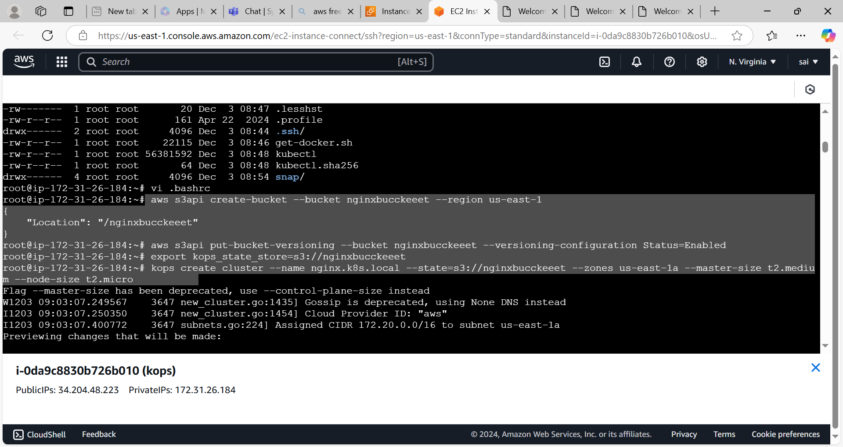

* Update the cluster

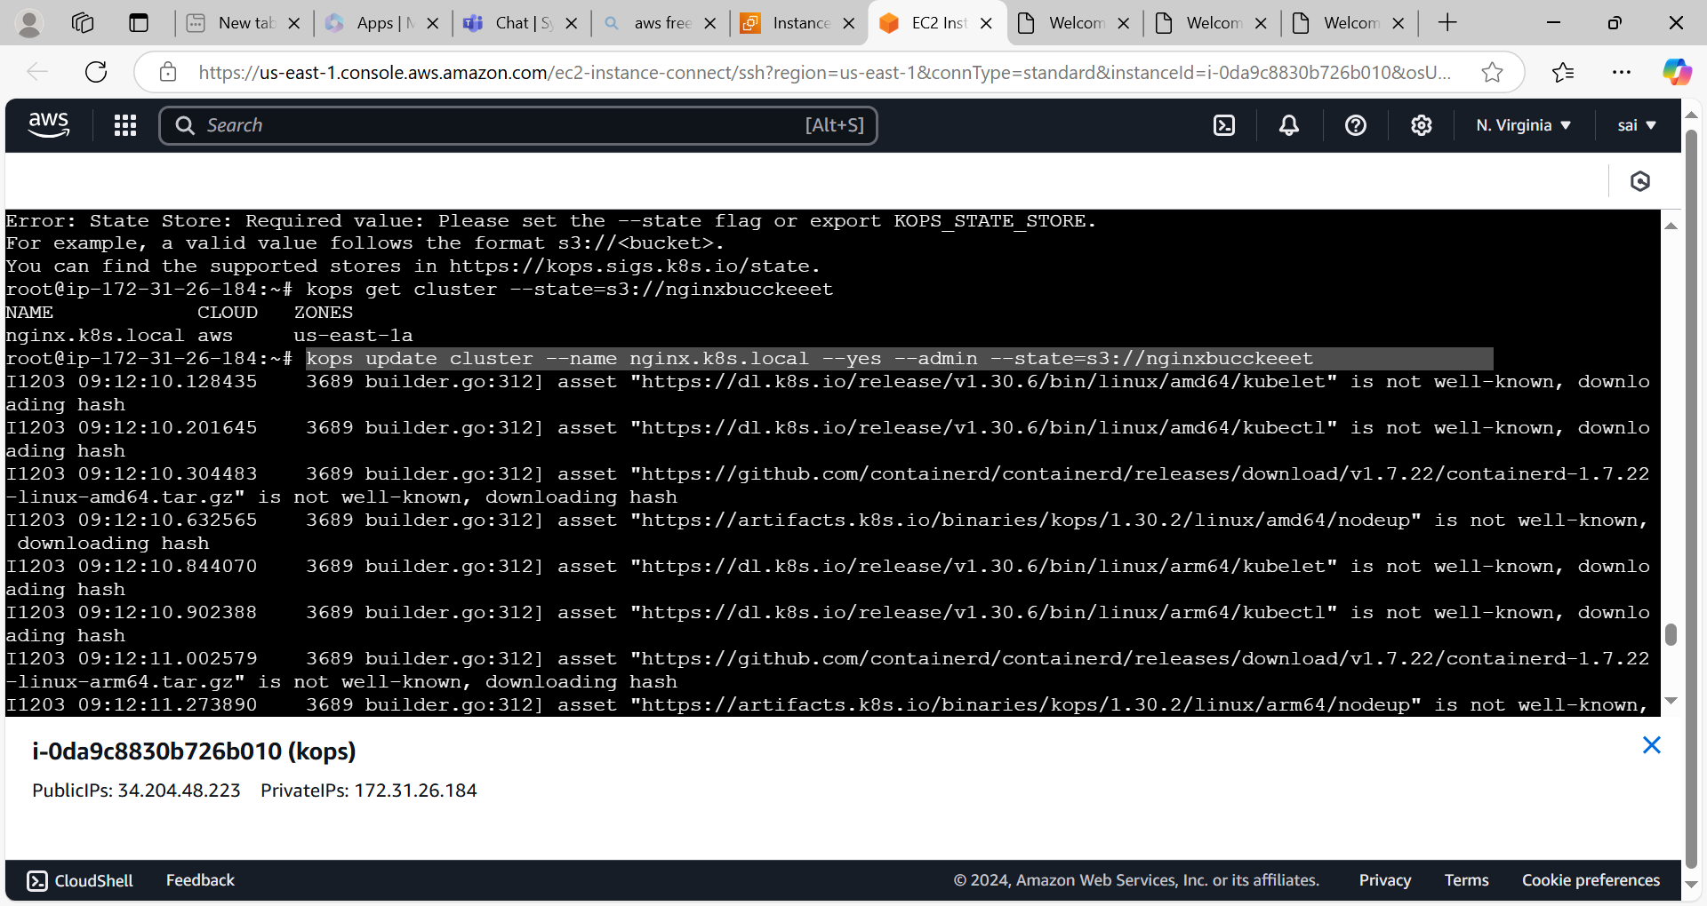

* It will create the instances,load balancer and asg.

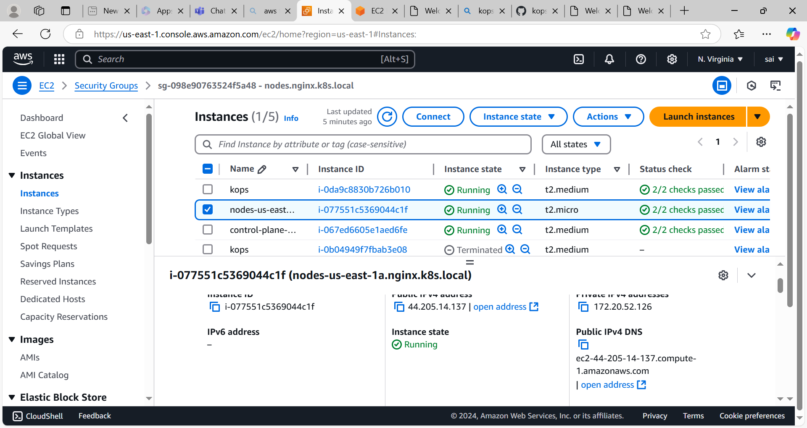

* Create the deployment file by using **vi filename.yml** command.

apiVersion: apps/v1  
kind: Deployment  
metadata:  
  name: sample-dep  
spec:  
  replicas: 2  
  selector:  
    matchLabels:  
      app: hello-app  
  template:  
    metadata:  
      labels:  
        app: hello-app  
    spec:  
      containers:  
       - name: container1  
         image: nginx:latest  
         ports:  
         - containerPort: 80

* Create the nodeport service yml file

apiVersion: v1  
kind: Service  
metadata:  
  name: hello-app  
  labels:  
    app: hello-app  
spec:  
  type: NodePort  
  ports:  
  - port: 80  
    targetPort: 80  
    protocol: TCP  
  selector:  
    app: hello-app

* Access the application by using worker node ip with nodeport

